Crime Reporting System

-Sem 6 Project

Soham Deshmukh

TYBBA – CA

Roll number: 17

INDEX

Introduction [3]

Objective [4]

Types of Users and their Roles [5]

Diagrams [6-7]

Tables and Structures [8]

Testing [9]

Manual [10-18]

Conclusion [19]

INTRODUCTION

The recent history of crime reporting in India reveals a concerning trend of increasing incidents, prompting government initiatives like the Indian Cyber Crime Coordination Centre and National Cyber Crime Reporting Portal, alongside awareness campaigns by CERT-In to address rising cyber threats.

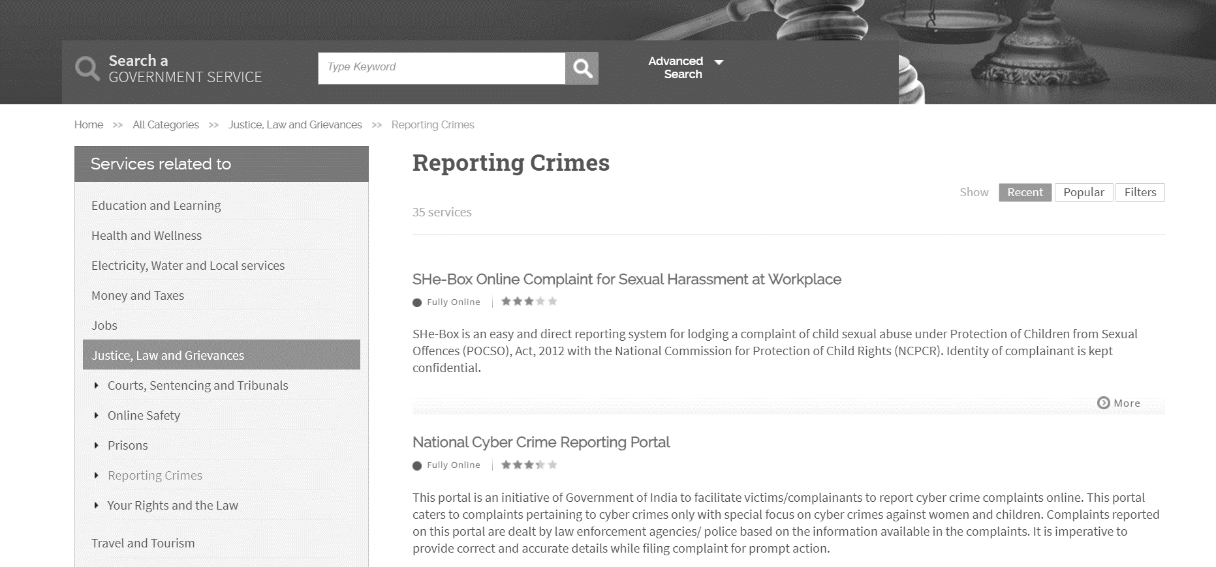

*Source: https://services.india.gov.in/service/listing?cat_id=84&ln=en*

However, the existing systems in India are facing **challenges** in **raising awareness**, ensuring **timely and effective responses** to cybercrime complaints, and **enhancing coordination** among various agencies involved in battling cybercrimes online.

I have taken up this project to visualize how the existing system works and address the challenges faced in cybercrime reporting. Furthermore, I have considered how different departments at various levels interact with each other, aiming to improve coordination and response mechanisms.

Citations:

*[1]* [*https://cybercrime.gov.in*](https://cybercrime.gov.in)

*[2]* [*https://www.iasparliament.com/current-affairs/crime-in-india-2022*](https://www.iasparliament.com/current-affairs/crime-in-india-2022)

OBJECTIVE

The Crime Reporting System offers victims/complainants and police officers a simpler way to report and handle complaints about crimes.

It is a space where individuals can seek help, and authorities can efficiently manage reported incidents, making the process smoother and more accessible for everyone involved.

Summary of Objectives:

**Simplify Reporting:** The Crime Reporting System aims to simplify the process of reporting crimes for victims/complainants and law enforcement officers.

**Efficient Handling:** It provides a virtual space where authorities can efficiently manage and address reported incidents, ensuring a prompt response to complaints.

**Accessibility:** By offering a user-friendly interface, the system makes it easier for individuals to seek help and for authorities to handle reported crimes effectively.

**Streamlined Process:** The system aims to streamline the crime reporting process, making it smoother and more accessible for all parties involved.

Consider the following scenario,

Imagine a concerned citizen witnessing a burglary in their neighbourhood and promptly reporting it to the local police station.

The Crime Reporting System streamlines this process by allowing the witness to provide essential details about the incident, such as the location, time, and description of the suspects, through a user-friendly interface.

As a result, law enforcement officers can efficiently handle the reported burglary, allocate resources effectively, and coordinate with other departments to apprehend the suspects and prevent further criminal activity, ensuring the safety and security of the community.



*Free (no copyright image) -* [*https://pixabay.com/photos/hands-phone-smartphone-electronics-1851218/*](https://pixabay.com/photos/hands-phone-smartphone-electronics-1851218/)

TYPES OF USERS AND THEIR ROLES

1. **Complainer:** The complainer is an individual who registers complaints within the system by creating an account. They can track updates on their complaint, ensuring transparency and engagement throughout the resolution process.
2. **Police Officer:** The police officer plays a crucial role in the system by reviewing assigned complaints and updating case details as necessary. They provide Case Updates and the Final Report.
3. **In charge (Police Station):** The in charge at the police station level is responsible for overseeing the management of complaints within their jurisdiction. They have the authority to view relevant complaints, manage police officers under their command, and assign complaints to appropriate personnel.
4. **Headquarters:** Operating at a higher level, the headquarters personnel have oversight of the entire complaint management system. They possess the authority to view all complaints and manage police stations across different regions.

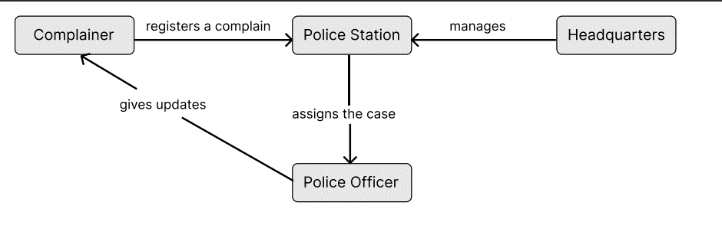

Class Diagram

A class diagram is a visual representation of the structure and relationships of classes in a system.

In this context,

The class diagram depicts classes such as "Complainer," "Police Officer," "Incharge," and "Headquarters," each representing **different roles** in the complaint handling system.

Associations between these classes illustrate how they **interact,** with **attributes** and **methods** specifying their **responsibilities** and **functionalities.**

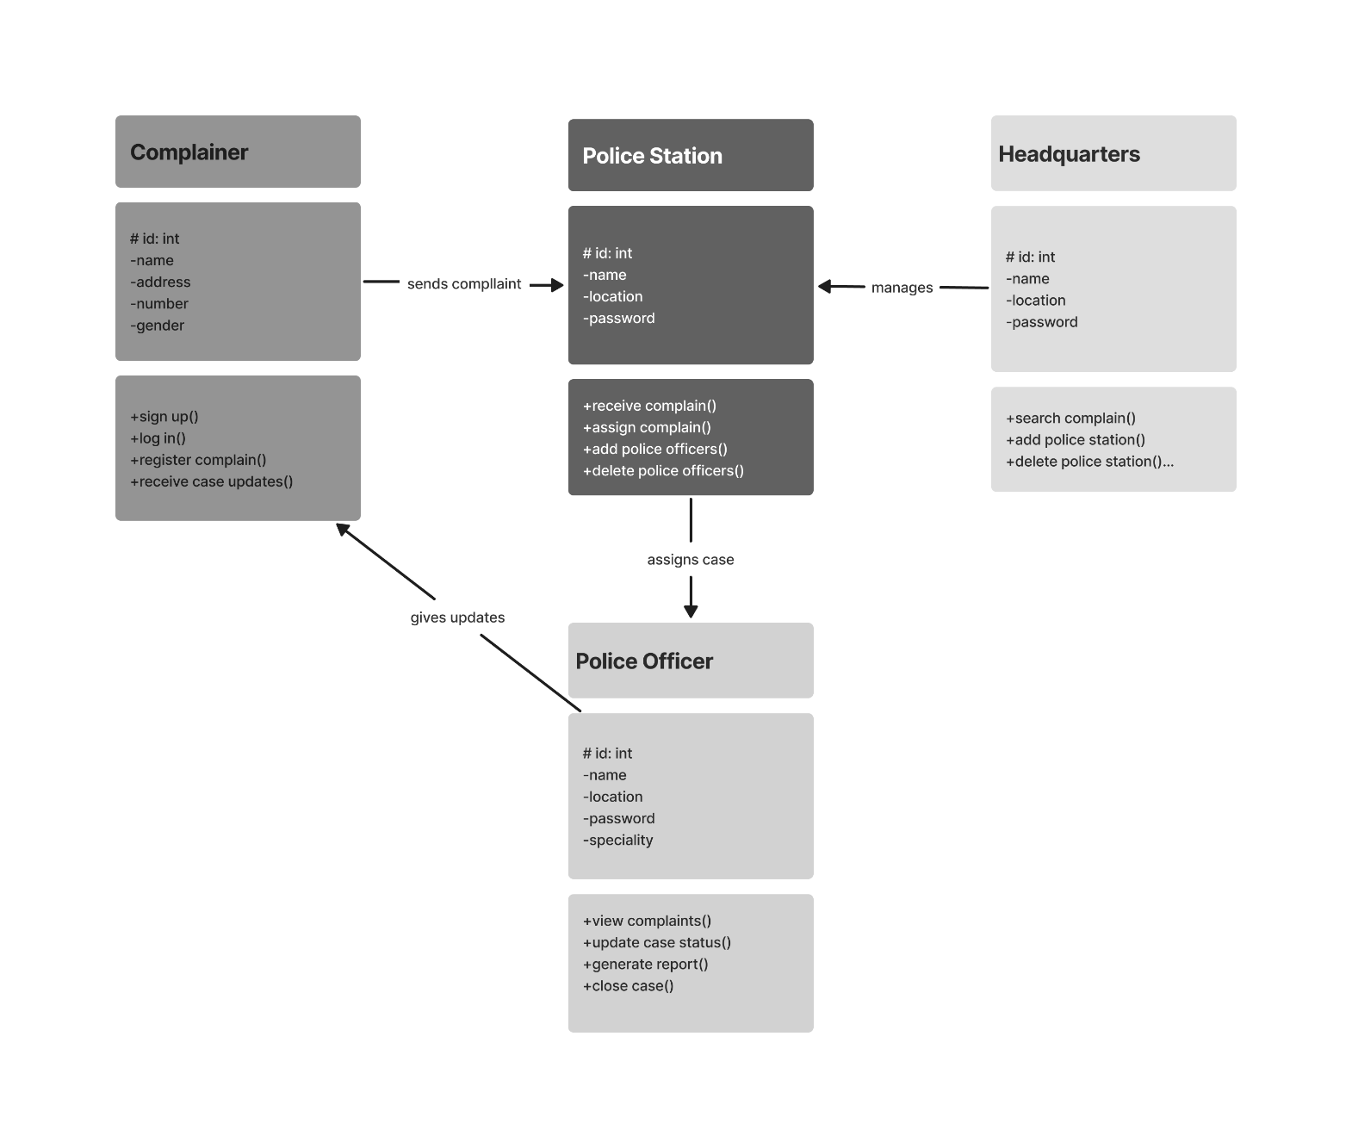

Sequence Diagram

A sequence diagram is a type of interaction diagram that visualizes the interactions between objects or components in a system over time, showing the sequence of messages exchanged between them.

In this context,

the sequence diagram illustrates the **chronological flow** of interactions between various system components, such as Complainer, The Digital System, and the Crime Department depicting how they communicate and collaborate in handling complaints and managing crime incidents.

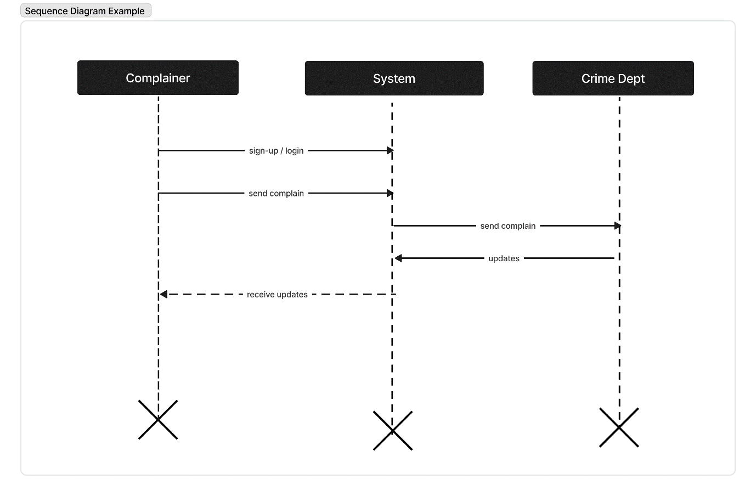

TABLES AND STRUCTURES

**MySQL (with Wamp Server)** was used for managing the backend. The following tables were created to store the data.

Table: User

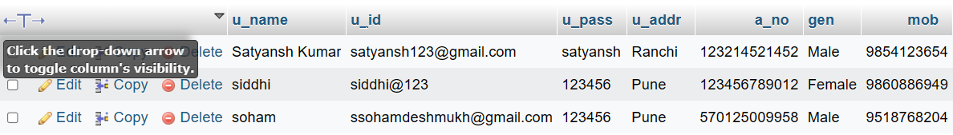

Table: Police Officer

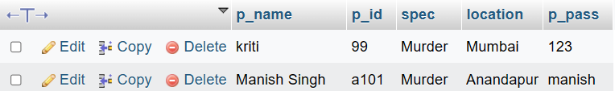

Table: Police Station (In charge)

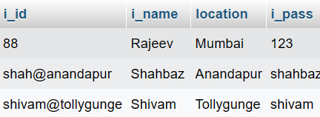

Table: Headquarters

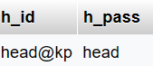

Table: Complaint

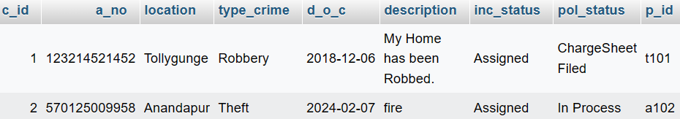

TESTING

Performing test cases on the software was necessary for ensuring that the app functions correctly and meets the specified requirements, thereby enhancing its reliability and quality.

|  |  |  |  |
| --- | --- | --- | --- |
| **SR NO** | **TEST CASE** | **STATUS** | **COMMENTS** |
| 1 | Signing up and logging in of all types of users | PASS |  |
|  |  |  |  |
| 2 | Reporting a Crime | PASS | Needs more details like understanding the priority level and uploading witness details. |
|  |  |  |  |
| 3 | Viewing and Assigning a Case | PASS |  |
|  |  |  |  |
| 4 | Managing members –  Valid Users can add, delete the members over which they have authority.  (Headquarters -> Police Station,  Police Station -> Police Officer) | PASS |  |
|  |  |  |  |
| 5 | Search Functionality –  Users can search up details from the database (only the details they have access to) | PASS | Needs to be flexible (Some cases are only searchable from their ID number. There should be an option to be able to search them up from other details) |
|  |  |  |  |
| 6 | Police officer can update case status. | PASS |  |
|  |  |  |  |
| 7 | Person who made the complaint can track their complaint status | PASS |  |
|  |  |  |  |
| 8 | Users can navigate through the website seamlessly –  accessing various features and functionalities with ease, thereby enhancing their overall user experience and satisfaction. | FAIL | Needs proper navigation system |

MANUAL

From the perspective of a person who must file a complaint,

1) Go to the website to **Register** yourself.

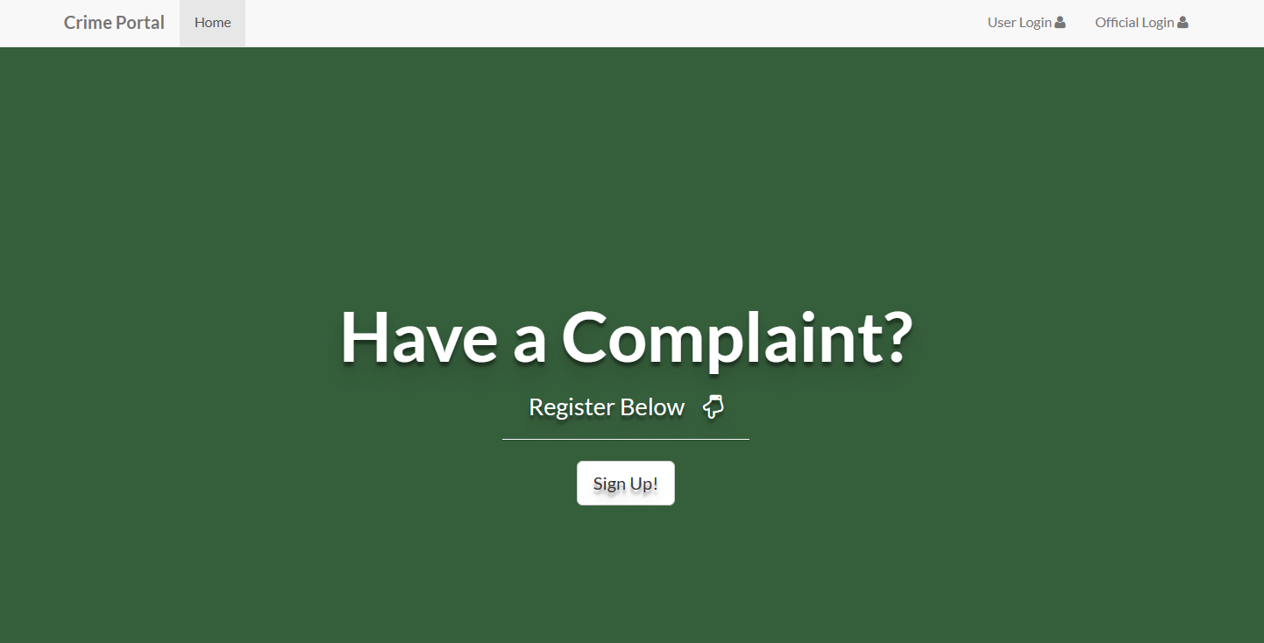

2) You must **fill in your details** to Register.

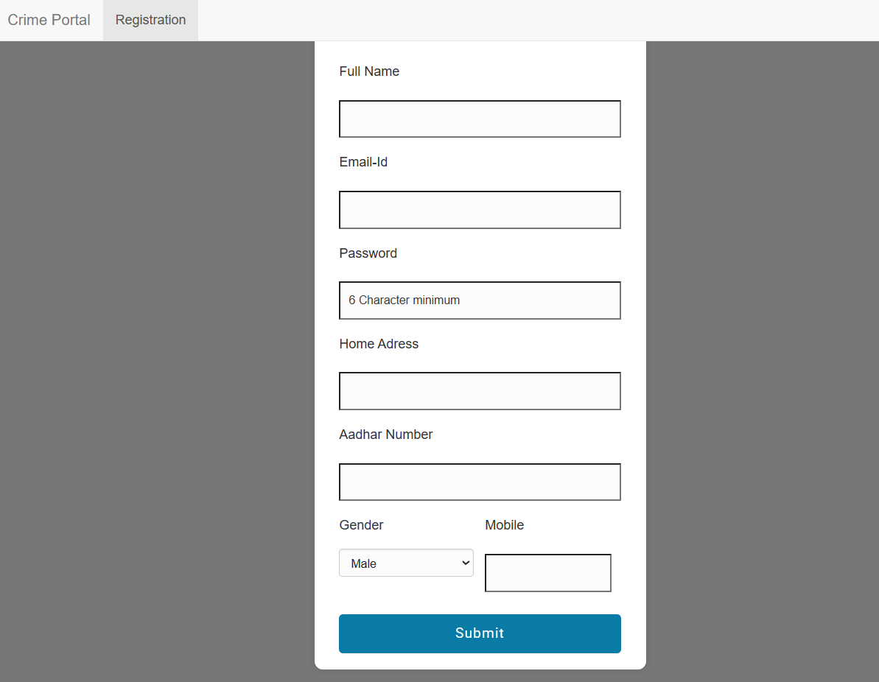

3) You can check your **Complaint History** (in case you have made Multiple Complaints).

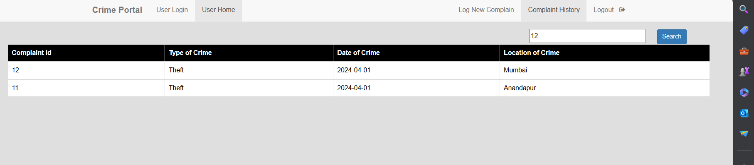

4) You can **track** and **get updates** about the filed Complaint – This consists of details like the current stage of the Case, the Time period needed, etc.

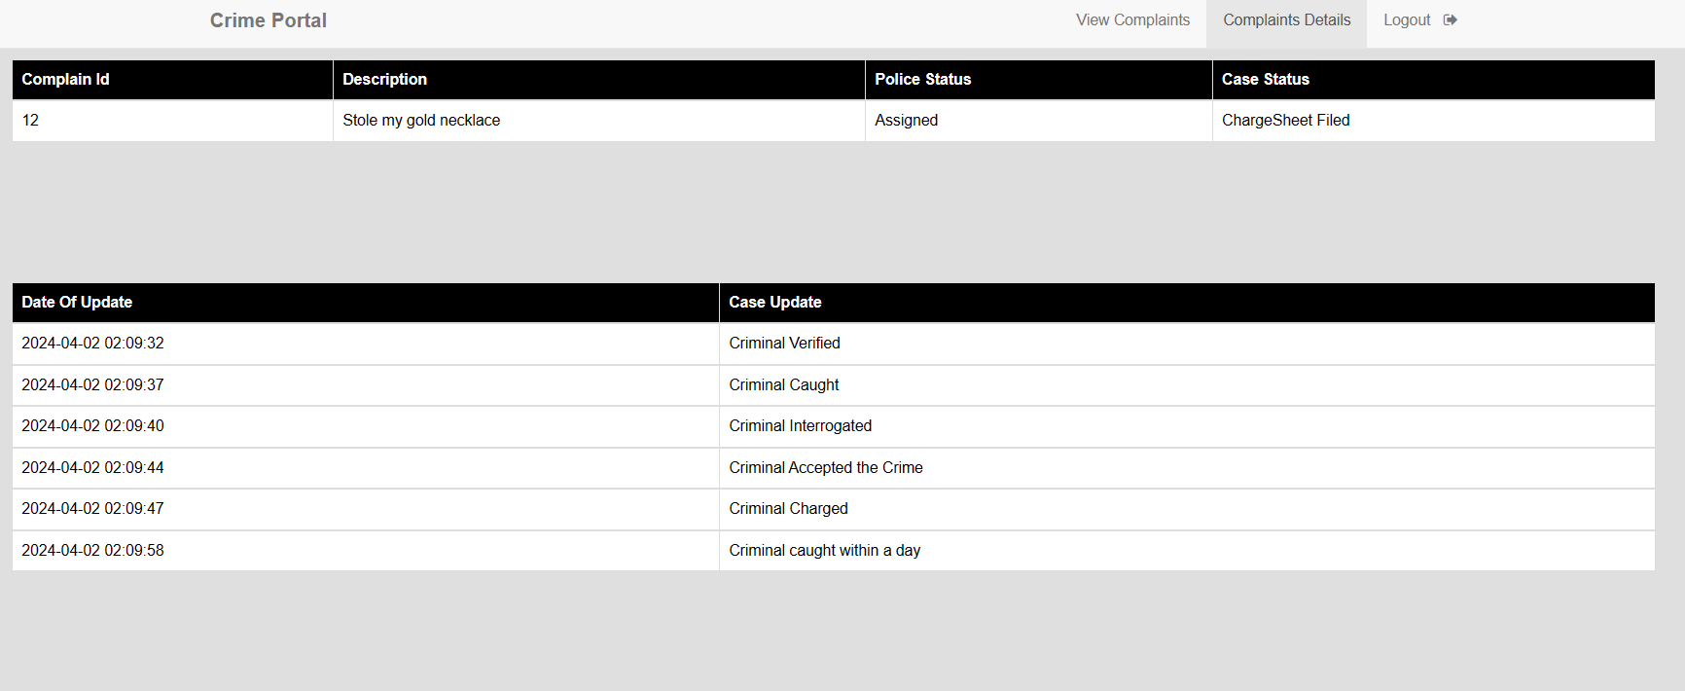

Official Login

Incharge Login

From the perspective of the Station Incharge,

(The in charge at the police station level is responsible for overseeing the management of complaints within their jurisdiction. They have the authority to view relevant complaints, manage police officers under their command, and assign complaints to appropriate personnel.)

1) Go to the Official Login page.

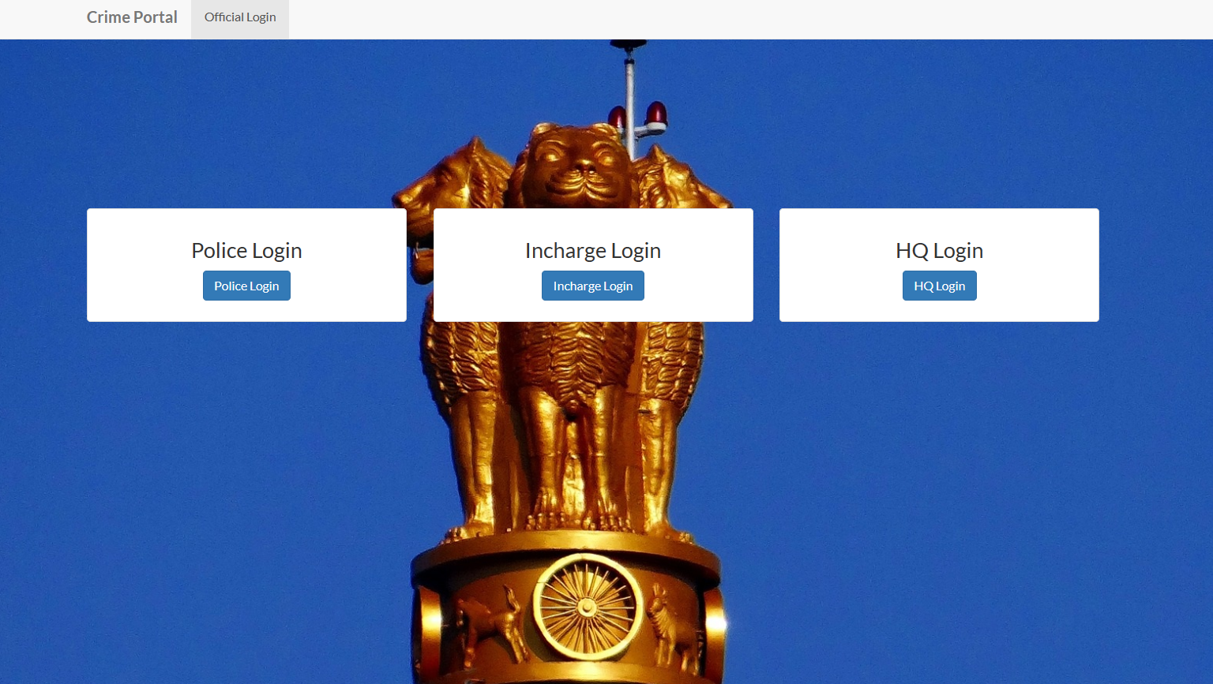

2) Log in using Id and Password.

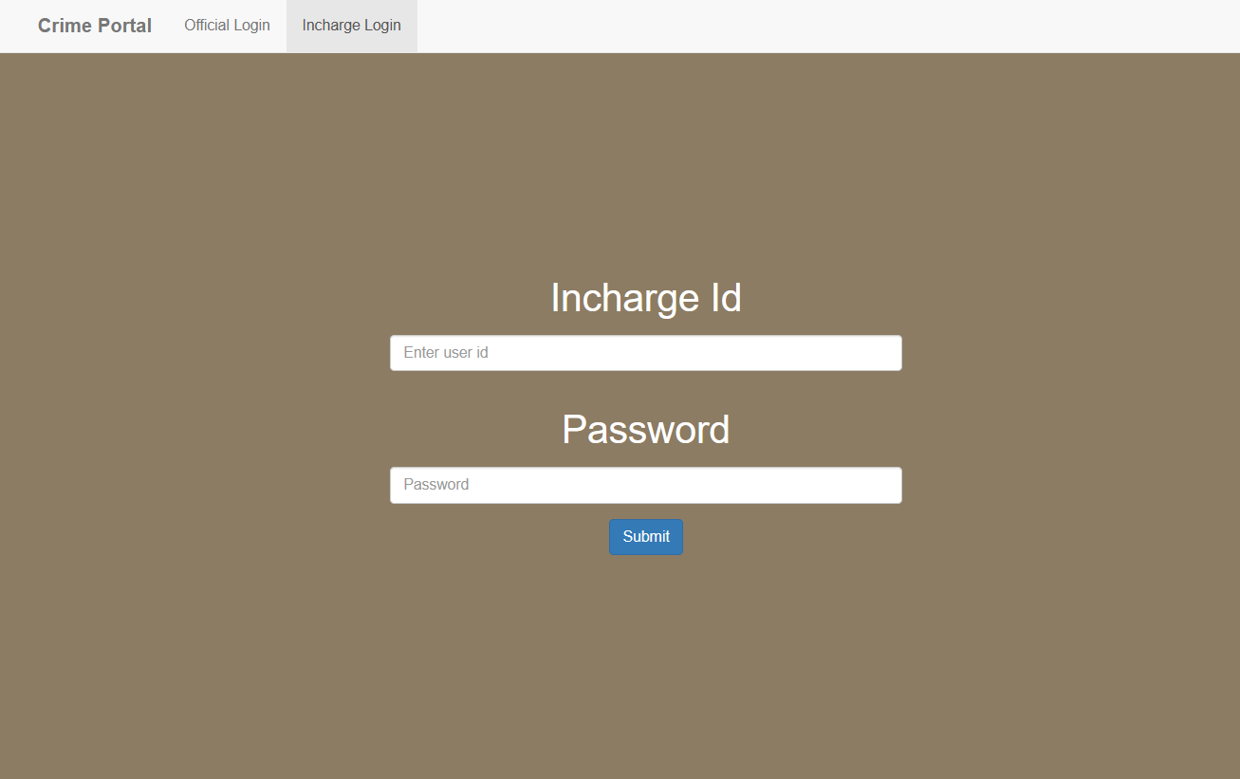

3) View list of Complaints registered.

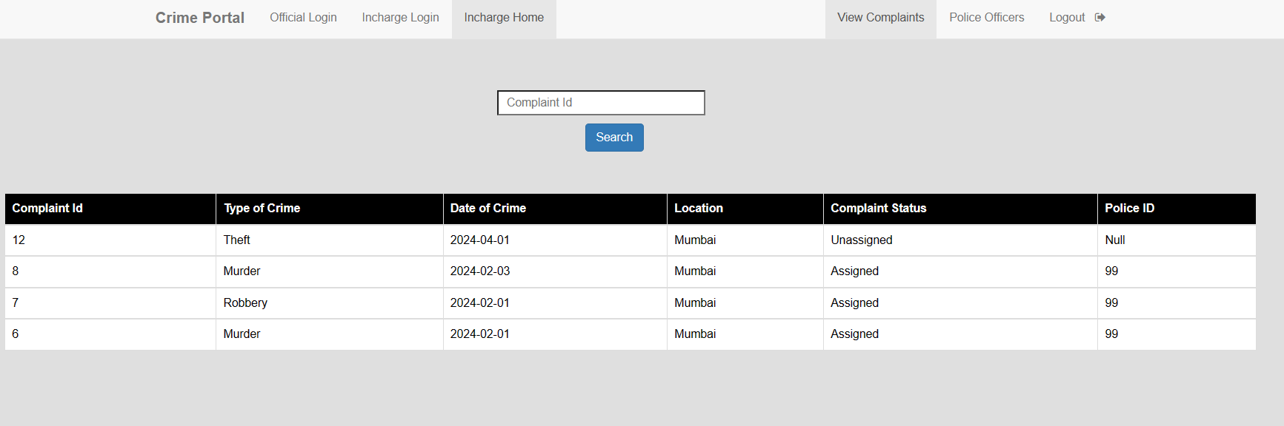

4) **View Specific Complaint** and **Assign the Complaints** to the Officers.

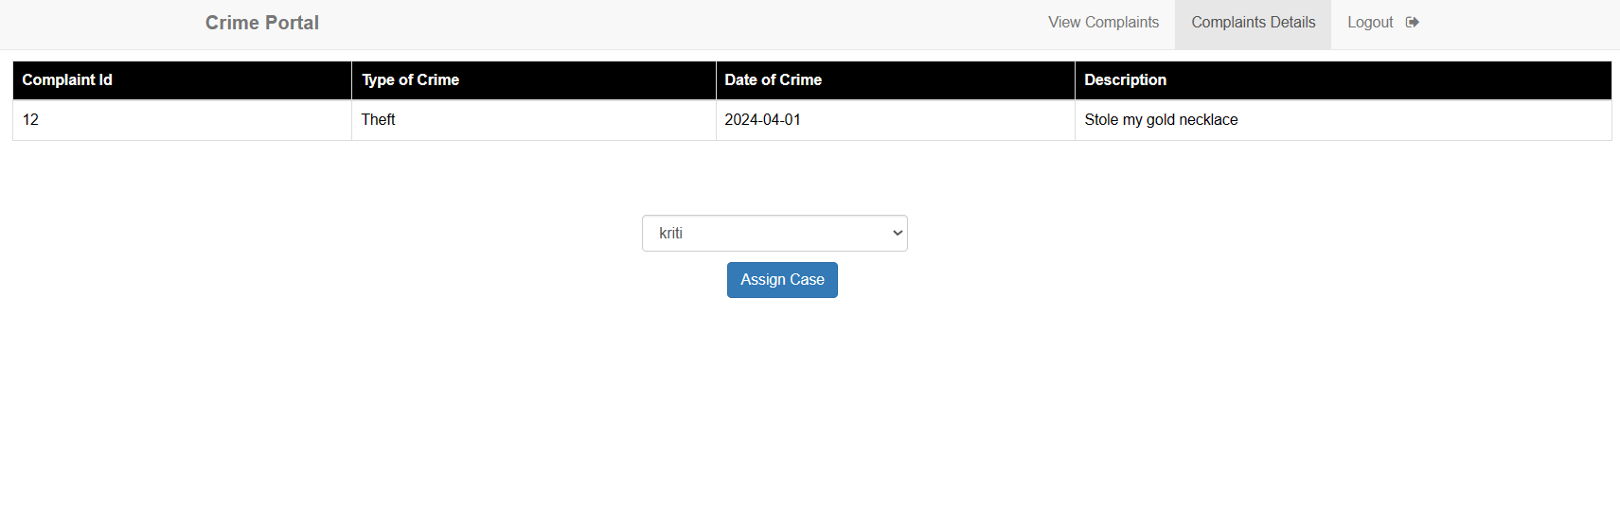

5) Manage Officers (Add / Delete).

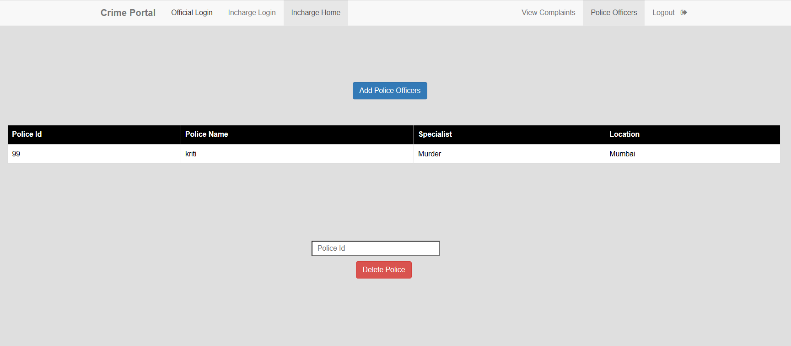

Police Officer

(The police officer plays a crucial role in the system by reviewing assigned complaints and updating case details as necessary. They provide with Case Updates and the Final Report.)

1) Go to the Official Login page.



2) Log in using Id and Password

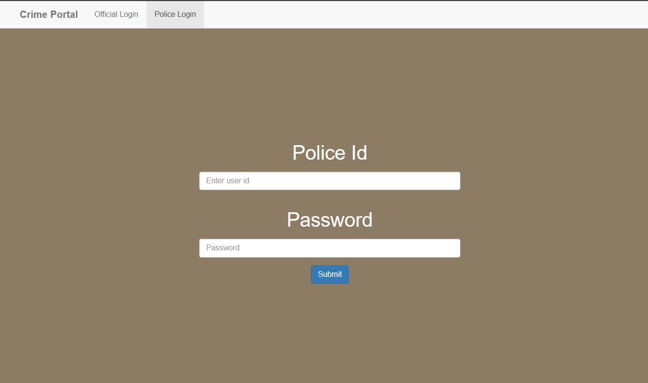

3) View Assigned Complaints.

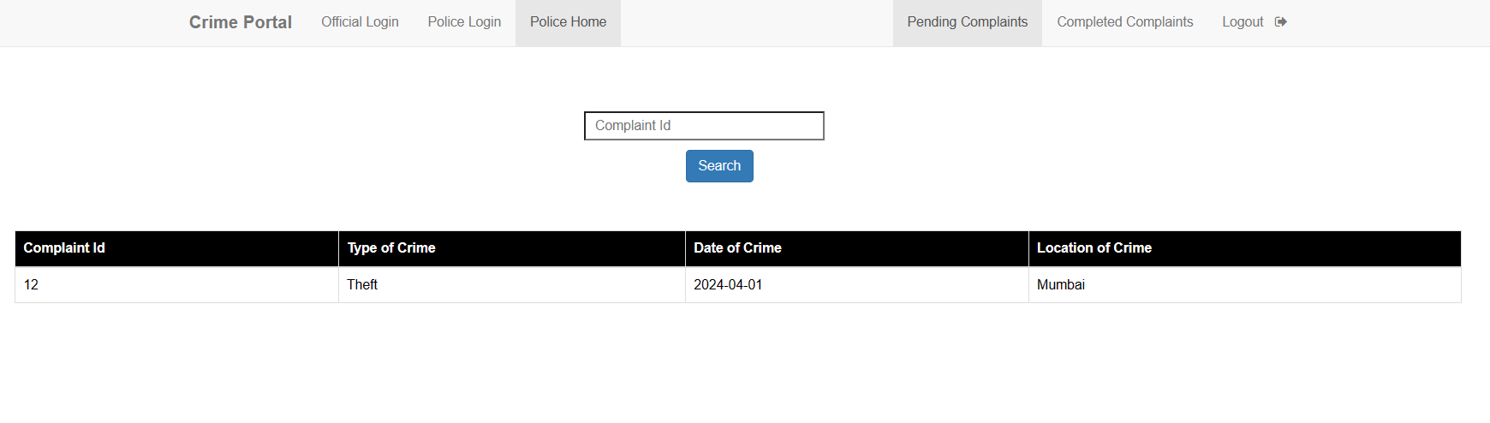

4) Access a **specific Complaint** and **Update Status** as Necessary.

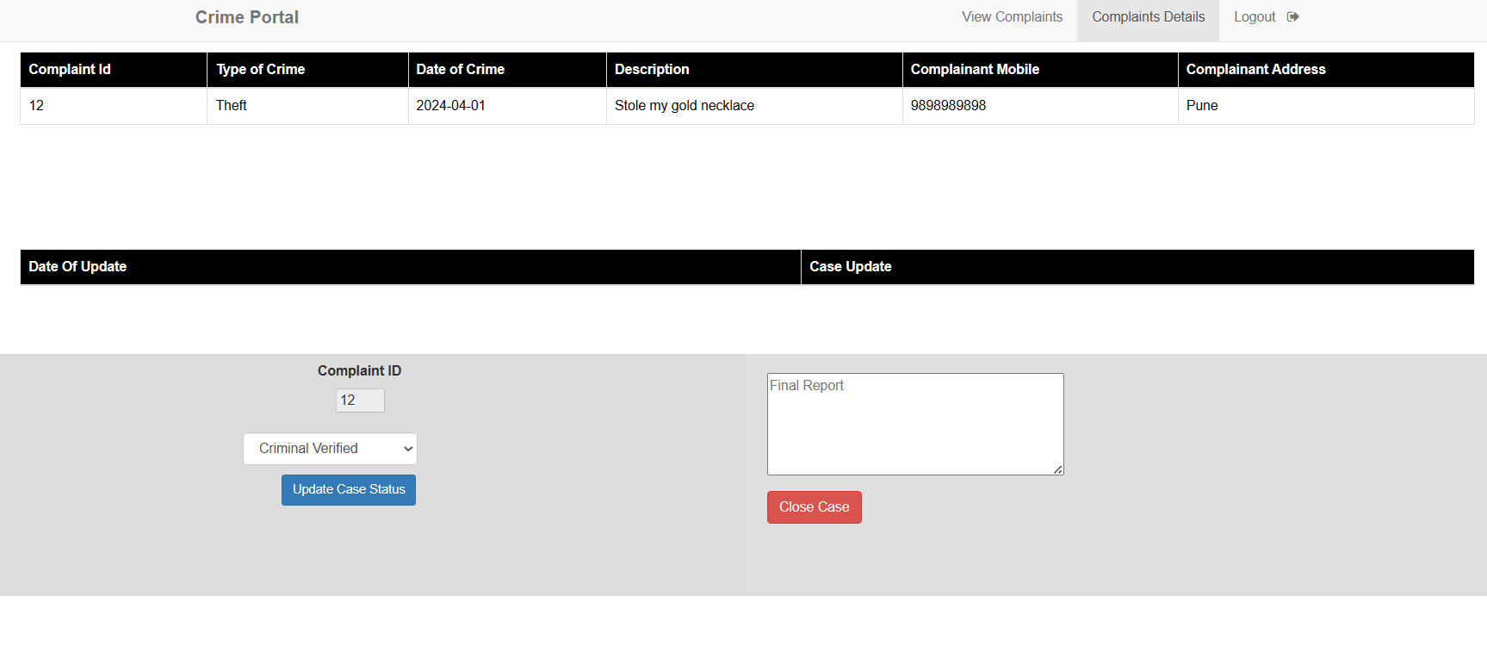

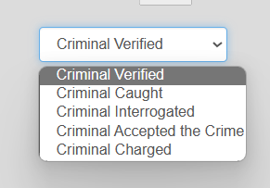

5) **Close the case** after Case is **Completed**.

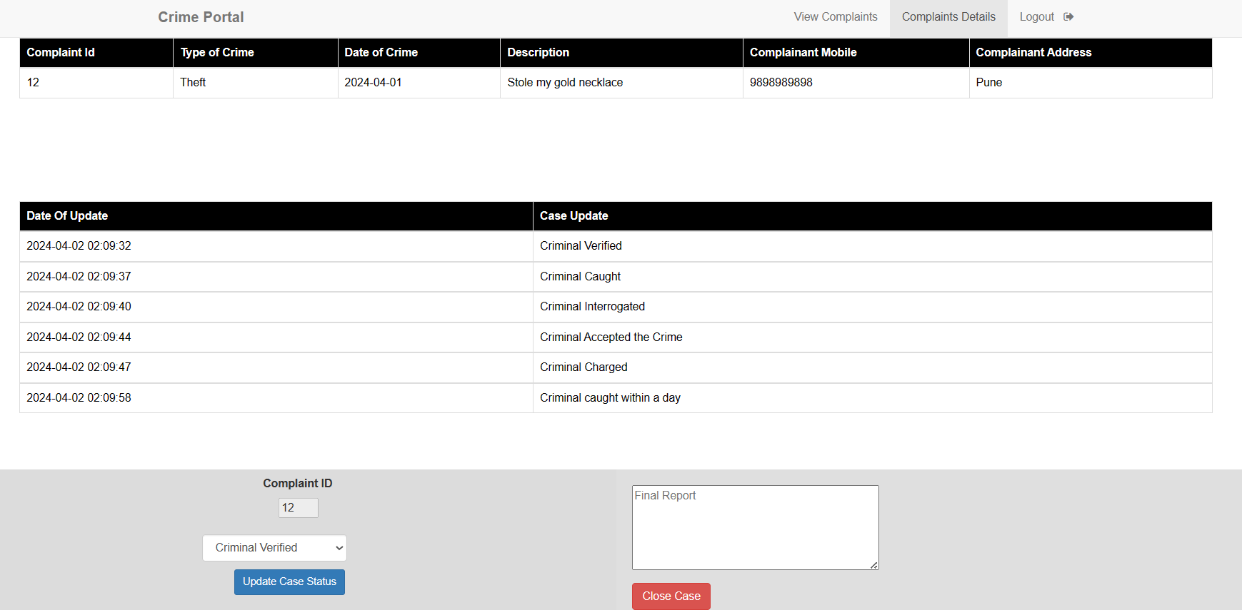

Head Quarter

(Operating at a higher level, the headquarters personnel have oversight of the entire complaint management system. They possess the authority to view all complaints and manage police stations across different regions. )

1) Go to the Official Login page.



2) Log in using Id and Password.

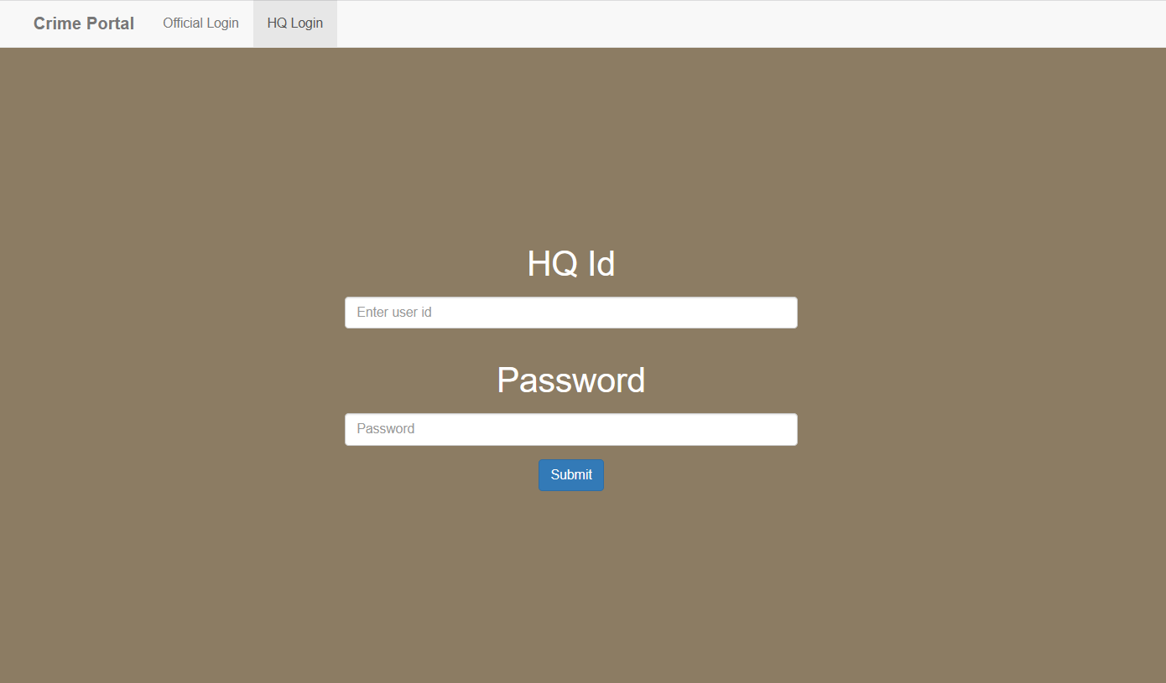

3) Search up a complaint to view its specific details.

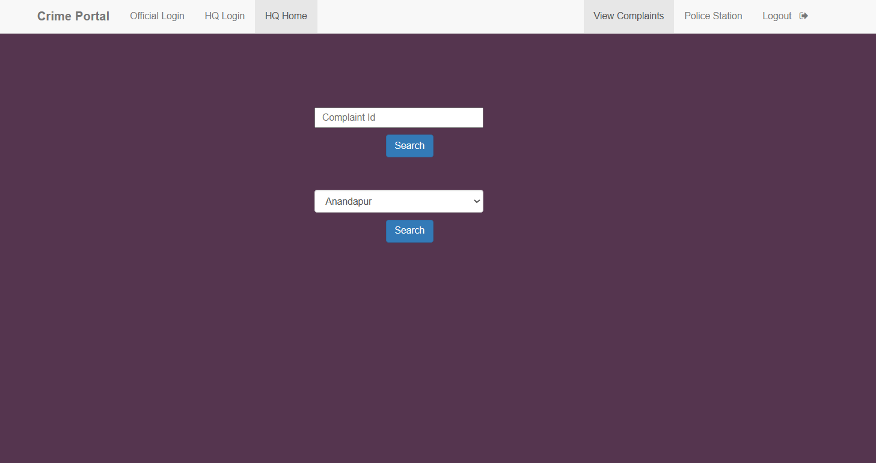

4) Manage Police Stations

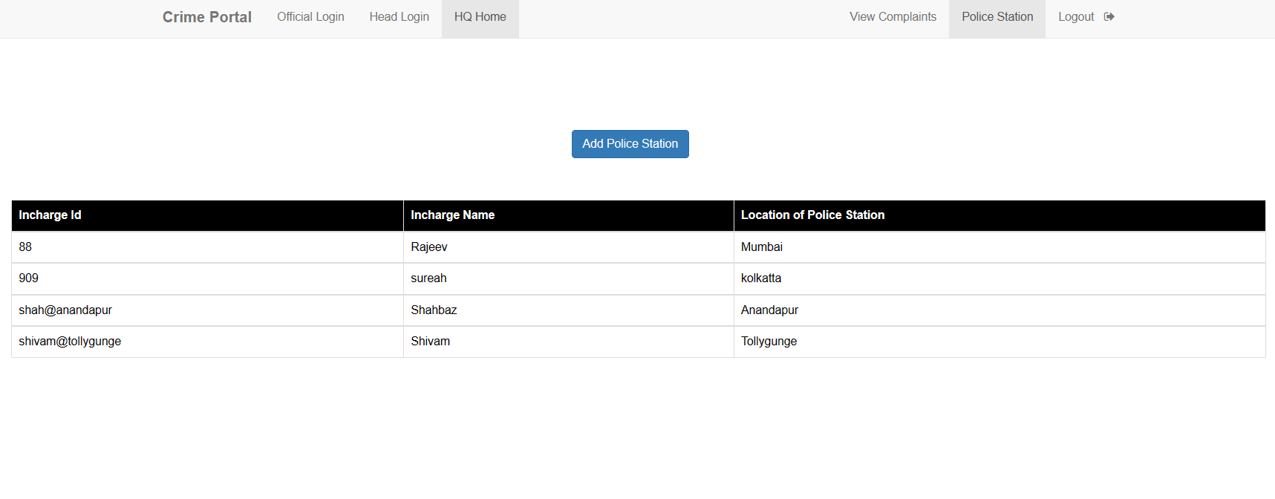

Conclusion

In conclusion, this project strives to revamp cybercrime reporting systems in India, focusing on overcoming current hurdles and fostering better collaboration.

By creating a user-friendly Crime Reporting System, both victims and law enforcement personnel can seamlessly report and address complaints.

Scope:

1. Implementation of a robust database management system to store and manage reported incidents securely.

2. Conducting user testing and feedback sessions to refine the Crime Reporting System for optimal usability and effectiveness.